Heinrich Hertz Technical Paper 2020

By James Duffy (17206286) and Eoin Flynn (15179818)

University of Limerick
E-mail: 17206286@studentmail.ul.ie
15179818@studentmail.ul.ie

ABSTRACT

Put your abstract here… It should be concise, no more than 300 words.
Before the abstract, the authors’ names should be centered below the title and should be in Time New Roman 12 points. The address should be centered below the author’s name and should be in Time New Roman 10 points. Please include your E-mail address. The initial title should be centered across the top of the first page and should be in Time New Roman Bold 18 points.

I. Introduction

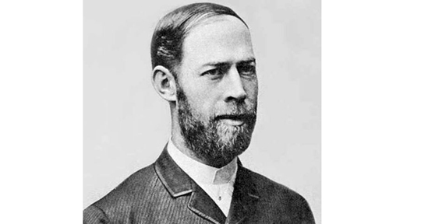

Figure 1.1 – Heinrich Hertz
Heinrich Rudolf Hertz was born in February 22, 1857 in Hamburg and died January 1, 1894. He showed that the Scottish physicist James Clerk Maxawell’s studies and theory on electromagnetism was indeed correct, proving that light and heat are forms of electromagnetic radiation.

II. Background

A. Subsection Title

Provide figures with their captions within the text. All illustrations and pictures should be high-contrast black and white (not color) prints.
References should be cited, at the end of the paper, in numerical order in which they appear in the text. When citing reference in the text, type the corresponding number in square brackets as shown at the end of this sentence: [1]. References should be complete and in standard IEEE style.

B. Instructions for 8 ½’’ x 11’’ paper :

The distance from the top edge of the paper to the top of the first line (i.e., the title) should be 23 mm. Left and right margins should be the same (19 mm). The width of each column should be 84 mm. The distance between the two columns of the text should be 10 mm. The distance from the bottom edge of the paper to the bottom of the last line of type on all page should be no less than 20 mm ; this allows room to insert the copyright notice and page numbers in the final version.

C. Instructions for A4 paper:

The distance from the top edge of the paper to the top of the first line (i.e., the title) should be 30 mm. Left and right margins should be the same (16 mm). The width of each column should be 84 mm. The distance between the two columns of the text should be 10 mm. The distance from the bottom edge of the paper to the bottom of the last line of type on all page should be no less than 26 mm ; this allows room to insert the copyright notice and page numbers in the final version.

III. Influences
IV. Technological Achievements
V. Impact and Applications

X. CONCLUSIONS

The conclusions of your paper. Future work directly from the paper is also acceptable.
This Word template for A4 pages has already defined styles for use in the paper.

REFERENCES

[1] A.B. Author, Book Title, New York: IEEE Press, ch. 6, pp. 23-35.
[2] C.D. Author, "Paper Title", Journal, vol. 8, 1997, pp. 1-10.
[3] E.F. Author, "Paper Title", in Proceedings of Conference, 1996, pp. 30 -34.

Photoelectric Effect Technological Achievement:

In 1887, Heinrich Hertz discovered the photoelectric effect. In connection to Hertz’ work on radio waves he observed and reported on the production and reception of electromagnetic waves caused by the photoelectric effect.

The observation Hertz made was that when ultraviolet light shines on two metal electrodes with a voltage applied across them, a spark occurs between the two electrodes as the light alters the voltage. Hertz made two obervations from this, the photoelectric effect and the production and reception of electromagnetic waves, these observations were published in the journal Annalen der Physik.
Another German physicist named Philipp Lenard added further clarification to this. Philipp demonstrated the liberation of electrically charged particles from the surface of a metal when it is illuminated. These liberated were found to be identical to electrons which had been discovered by the British physicist Joseph John Thomson in 1887.

The photoelectric effect was found to represent an interaction between light and matter that at the time could not be explained by classical physics, in which light is described as an electromagnetic wave. According to wave theory the maximum kinetic energy of the electrons released due to the photoelectric effect should have been proportional to the intensity of the light, but rather it was varying in proportion to the light’s frequency instead. The lights intensity instead determined the number of electrons released from the metal, which was measured as an electrical current. A second puzzling observation was that the time between the arrival of radiation and the emission of electrons had virtually no lag between them.

(needs work) His receiver consisted of a coil with a spark gap, whereby a spark would be seen upon detection of EM waves. He placed the apparatus in a darkened box to see the spark better. He observed that the maximum spark length was reduced when in the box. A glass panel placed between the source of EM waves and the receiver absorbed UV that assisted the electrons in jumping across the gap. When removed, the spark length would increase. He observed no decrease in spark length when he substituted quartz for glass, as quartz does not absorb UV radiation. Hertz concluded his months of investigation and reported the results obtained. He did not further pursue investigation of this effect, nor did he make any attempt at explaining how the observed phenomenon was brought about.
This went on to be dubbed the Hertz effect and was further investigated by Hallwachs, Hoor, Righi and Stoletov on the effect of light.
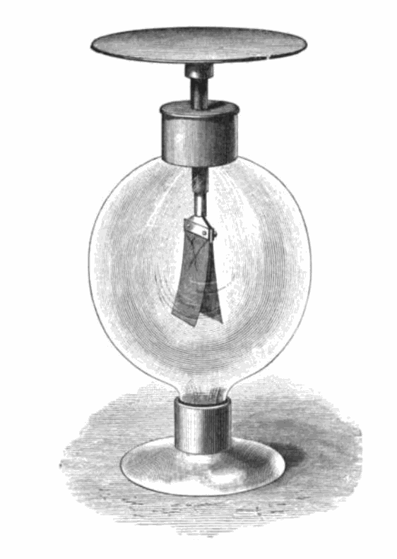
Fig.1 Gold leaf electroscope used to demonstrate the photoelectric effect.

Photoelectric Effect Impact and Applications:

The impacts of Hertz’ discovery of the photoelectric effect is significant and broad, especially when looking at how it laid the foundations for many modern technological achievements.

Hertz’ work became the foundation for many scientists to investigate the photoelectric effect. Hertz lead other scientists to discover many important concepts and qualities of light, some of which include:
- Under certain circumstances light can ionize gases – Philipp Lenard in 1900
- The concept of photoelectric emission – Philipp Lenard and Wilhelm Hallwachs 1886-1902
- Light energy is carried in discrete quantized packets, the energy in each packet is equal to the frequency of light multiplied by a constant, called Planks constant, key in developing quantum mechanics – Max Plank in 1900, Albert Einstein in 1905 proven by Robert Millikan in 1914
- The photoelectric effect propelled the emerging concept of wave-particle duality in the nature of light. This concept in essence means that light possesses the characteristics of both waves and particles. The effect was impossible to understand with the widely accepted wave description of light at the time.

The uses and effects of the photoelectric effect are seen in the following:
Photomultipliers, image sensors, photoelectron spectroscopy, night vision devices, spacecraft, moon dust.

A photoelectric cell, otherwise known as photodiode. This was originally a cathode made with a small work function so that electrons would easily be emitted placed inside a vacuum tube. The released electrons are gathered by an anode which is held at a large positive voltage in relation to the cathode. This device has since been replaced by semiconductor-based photodiodes that can detect light, measure light intensity, control other devices as a function of illumination, and turn lights energy into electrical energy. These devices are used in industrial process control, pollution monitoring, light detection withing fiber optics of telecommunications networks, solar cells, imaging and a broad range of other applications.

A photoconductive cell is made of semiconductors with bandgaps that corresponding to the sensed photon energies. Two examples of this are cadmium sulfide, and lead sulfide or mercury cadmium telluride.
Cadmium sulfide has use in automatic switches within streetlights, and photographic exposure meters which operate in the visible spectrum.
Mercury cadmium telluride has use in infrared detectors, which operate as sensors for night vision applications and operate outside of the visible spectrum.

A photomultiplier is a device that allows for the conversion of incident photons into an electric signal. A photomultiplier is made inserting a coated photocathode with very low work function inside of a vacuum tube that is extremely light sensitive. When the photocathode is illuminated by very low-level light it readily releases electrons. The photomultiplier contains a series of metal plated dubbed dynodes. The first dynode attracts the electrons released by the cathode, this dynode releases additional electrons that strike the second dynode and so on. The multiplication effect can be observed as the photocurrent is hugely amplified. The photomultiplier and its solid-state versions with comparable sensitivity are quintessential to spectroscopy research where the measurement of extremely weak light sources is commonplace. A photomultiplier is paired with scintillation counters which contain a material which produces flashed of light in response to being struck by X-rays or gamma rays, the use of the photomultiplier here is that it can count the flashes and measure their intensity. This seemingly simplistic application has invaluable uses such as identifying particular isotopes for nuclear tracer analysis and detecting the X-rays used in CAT scans, allowing cross sections of the body to be viewed.

Video camera tubes are a device based on cathode ray tubes that were used as television cameras to capture images. An example of this is the image dissector, which used a screen charged by the photoelectric effect in order to transfer the captured optical image into an electronic signal, which could then be broadcast over electromagnetic waves.

Cathode Rays Technological Achievement:

https://en.wikipedia.org/wiki/Cathode_ray

Hertz was part of the discovery of the electron, later proven by J. J. Thomson.
Hertz also theorized that cathode rays travelled in waves, also later proven by J. J. Thomson.
Hertz discovered that cathode rays could penetrate very thin metal foils. This ray effect was further researched by Hertz’ student Philipp Lenard. This lead to the production of X-rays. Mathematical theory was later formulated by a Hermann von Helmholtz.

Cathode Rays Impact and Applications:

TV my dude.

Contact Mechanics Technological Achievement:
???

Contact Mechanics Impact and Applications:
???

